The Office of the Federal Environmental Executive and the U.S. Environmental Protection Agency Present:

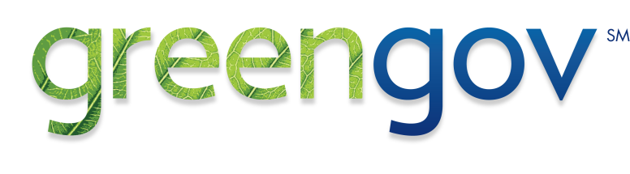

The GreenGov Webinar Series:
reducing federal energy use through smarter computer power management
Tuesday, August 3, 1:00 – 2:30 PM ET

President Obama’s Executive Order 13514 calls on agencies to lead by example in improving energy efficiency and reducing greenhouse gas pollution. Personal computers and other electronic devices are a major source of energy use for agencies, but effective use of power management (PM) tools can yield significant savings. According to the Department of Energy and Environmental Protection Agency (EPA), activating existing power savings features can cut PC energy usage in half, resulting in an average savings of $25-75 per computer.
We invite you to the first GreenGov Webinar to learn about PM strategies and tools Federal Agencies are using to achieve significant computer energy savings. The webinar will highlight success stories from across the Federal Government.
Featuring:

Effective computer PM 101
Cate Bernard, EPA

PM Tools you can use
Mike Walker, Beacon Consultants

Case Study 1: How to successfully deploy PM in your office
Michael Blake, EPA

Case Study 2: Alternative funding strategies for PM
Gregg Leifer, NIH or Gail Williams, NIH

Questions and Discussion

You must register in advance. Take the following steps to register:
- Visit https://www1.gotomeeting.com/register/890404449 to register.
- Complete the contact information on the following page.
- An e-mail with the information you need to participate in the presentation will be sent to the e-mail address you have specified. Please check your spam e-mail filter if the message does not appear in your inbox within 10 minutes of registering.
- On August 3, 2010, click on the link provided in the e-mail and join us at least 10 minutes prior to the start of the presentation. Then dial 1-866-299-3188, conference code 899999 to join the call.
About the Webinar:
This GreenGov Series Webinar will be approximately 90 minutes and is free of charge to attendees. You will need a high-speed Internet connection and a telephone line to interact with speakers and other participants.
Join the Discussion
We also invite you to share your own PM strategies on the GreenGov Collaborative, an online community of more than 1,200 Federal employees hosted by FedCenter.gov, and during the 2010 GreenGov Symposium, October 5-7 in Washington, DC.

If you have any questions please contact Amath Gomis, (202) 456-5141

